1.Please enter YML web site (http://www.yangming.com)



2.Please click e-Service [Member Login]

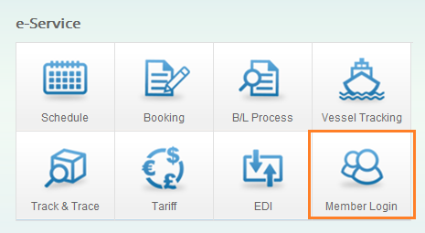

3.Please click [Register]

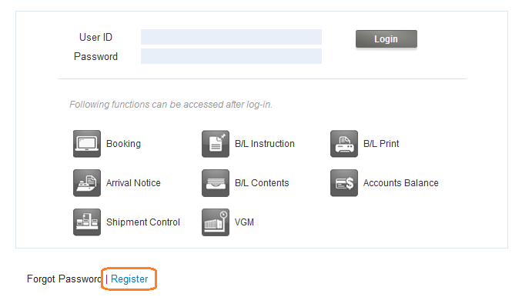

4.You will find page shown [Register], Fields marked with * are required

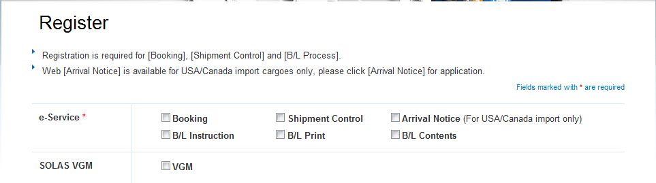

5.If you do not know who is the YM sales representative, please
key in [Un known] and submit

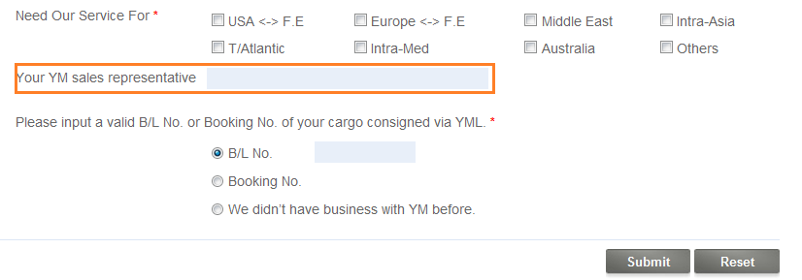
6.When you register successfully, you will have an auto mail with registration number, eg. 12345, person in charge will set up User ID
and password your utilization soon.

